Which of the following statement removes sales and suppliers database? 0.5

A. DROP DATABASE Sales, NewSales  
B. DROP DATABASE Sales, suppliers  
C. DROP DATABASE Sales and suppliers  
D. DROP DATABASE Sales-suppliers

Ans : B

Which of the following statements are TRUE? 0.5

A. A Unique constraint allows multiple rows to have NULL value  
B. Integrity constraint can be added to a table even if table data is in violation  
C. A PRIMARY KEY allows a single row to contain NULL  
D. Both A and B

Ans : A

1. Consider we have 30 employees where 20 of them belong to different departments and the rest don’t belong to any department. On the other hand, we have 4 departments where each of them have employees assigned to it. How many record will result by performing inner join between Table Employee and Department? 0.5

10

20

30

40

1. Consider we have 30 employees where 20 of them belong to different departments and the rest don’t belong to any department. On the other hand, we have 4 departments where each of them have employees assigned to it. How many record will result by performing full outer join between Table Employee and Department? 0.5

10

20

30

40

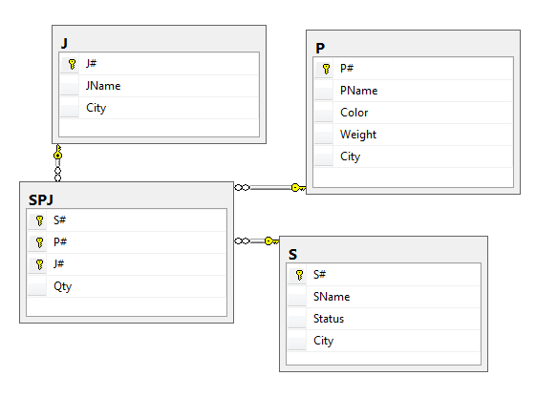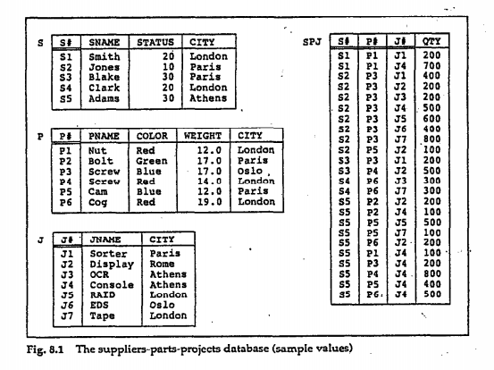

5- for each supplier, get supplier name and number of parts they supplied if any.

Correct answer:

select sname, COUNT(SPJ.p#)

from S left outer join SPJ

on S.s#=SPJ.s#

group by sname

incorrect answers:

select sname, COUNT(SPJ.p#)

from S right outer join SPJ

on S.s#=SPJ.s#

group by sname

select sname, COUNT(SPJ.p#)

from S , SPJ

on S.s#=SPJ.s#

group by sname

select sname, COUNT(SPJ.p#)

from S ,SPJ

on S.s#=SPJ.s#

1. 6- Given SPJ schema, Which of the following queries get the names of projects which supplied with parts of weight not less than 14 by suppliers located in London.

Correct answer:

select jname

from S, J, P, SPJ

where S.city='London'

and P.weight>= 14

and SPJ.p#=P.p#

and SPJ.j#=J.j#

and SPJ.s#=S.s#

incorrect answers:

1. select jname

from S, J, P, SPJ

where S.city='London'

and P.weight>= 14

and SPJ.p#=P.p#

and SPJ.s#=S.s#

/////////////////////////////

1. select jname

from J, P, SPJ

where S.city='London'

and P.weight>= 14

and SPJ.p#=P.p#

and SPJ.j#=J.j#

////////////////////////////////

1. select jname

from S, J, P, SPJ

where S.city= London

and P.weight>= 14

and SPJ.p#=P.p#

and SPJ.j#=J.j#

and SPJ.s#=S.s#

7- Given SPJ schema, what are the expected output of this query?

select distinct s#

from S,P,J

where S.city=P.city and P.city=J.city

correct answer:

(S1,S2,S3,S4)

Incorrect answers:

(S1,S1,S3,S4)

(S1,S2,S3,S5)

(S1,S2,S3,S5,S4)

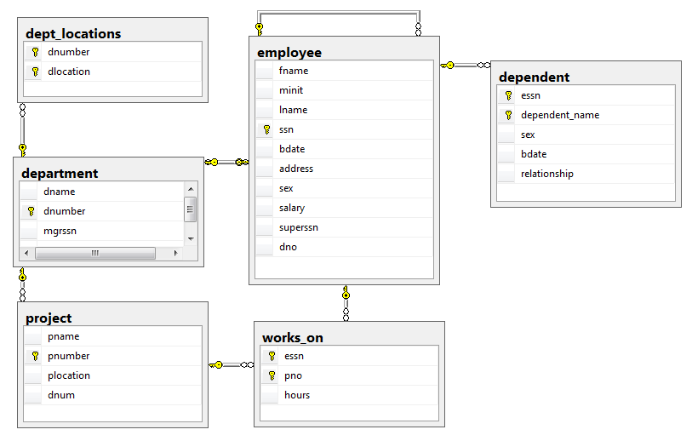

1. List each city and number of employees who work in projects in that city but they don’t live in it.

Select plocation, count(essn)

From project, works_on,employee

Where pnumber=pno and ssn=essn

And address <> plocation

Group by plocation

Incorrect answers:

Select plocation, essn

From project, works_on,employee

Where pnumber=pno and ssn=essn

And address <> plocation

Group by plocation

////////////////////////////////////

Select plocation, count(essn)

From project, works_on,employee

Where pnumber=pno and ssn=essn

And address = plocation

Group by plocation

/////////////////////////////////////

Select plocation, count(essn)

From project, works_on,employee

Where pnumber=pno or ssn=essn

And address <> plocation

Group by plocation

1. List the names of all employees who have a dependent with the same first name as themselves

Select fname

From employee e1

Where fname in (select dependent_name

From dependent d

Where e1.ssn=d.essn)

Incorrect answers:

Select fname

From employee e1

Where fname = (select dependent_name

From dependent d

Where e1.ssn=d.essn)

///////////////////////////////////

Select fname

From employee e1

Where fname = (select dependent_name

From dependent d

)

///////////////////////////////////

Select fname

From employee e1, dependent d

Where e1.ssn=d.essn or e1.fname=d.dependent_name

10-Which of the following queries would show the employees names who have never been supervisor to anyone before.

select fname

from employee

except

select e1.fname

from employee e1, employee e2

where e1.superssn=e2.ssn

select fname

from employee

except

select e1.fname

from employee e1, employee e2

where e1.superssn <> null

select fname

from employee

except

select e1.fname

from employee e1, employee e2

where e1.superssn is null

select fname

from employee

where superssn <> null

11- Consider the below table.  
Table Employee_Info

|  |  |  |
| --- | --- | --- |
| **ID** | **Department** | **Name** |
| 01 | Sales | Mark |
| 02 | Human Resources | John |
| 03 | Marketing | Suzy |
| 04 | Accounting | Adam |
| 05 | Engineering | Peter |
| NULL | NULL | NULL |
| 0 | 0 | 0 |

What is the result of the below query:  
  
select * from Employee_Info  
where '0' in (select ID from Employee_Info where ID in (0))

a)

|  |  |  |
| --- | --- | --- |
| **ID** | **Department** | **Name** |
| 0 | 0 | 0 |

b)

|  |  |  |
| --- | --- | --- |
| **ID** | **Department** | **Name** |
| NULL | NULL | NULL |

c)

|  |  |  |
| --- | --- | --- |
| **ID** | **Department** | **Name** |
| 01 | Sales | Mark |
| 02 | Human Resources | John |
| 03 | Marketing | Suzy |
| 04 | Accounting | Adam |
| 05 | Engineering | Peter |
| NULL | NULL | NULL |
| 0 | 0 | 0 |

d) None of the above.

12- You want all dates when any employee was hired. Multiple employees were hired on the same date and you want to see the date only once.  
  
Query - 1  
Select distinct hiredate

From hr.employee

Order by hiredate;

Query - 2  
Select hiredate

From hr.employees

Group by hiredate

Order by hiredate;

Which of the above queries is valid?  
  
A) Query - 1  
B) Query - 2  
C) Both

13- given northwind schema, which of these queries is correct to get product name and its id ordered by customers their address contains 'Granada' and contact title is 'Owner'or 'Marketing Manager'

Correct answer:

select Products.ProductID,ProductName

from dbo.Products,dbo.Orders,dbo.[Order Details],dbo.Customers

where dbo.Customers.CustomerID= dbo.Orders.CustomerID and dbo.Orders. OrderID=dbo.[Order Details].OrderID and dbo.Products.ProductID=dbo.[Order Details].ProductID

and Customers.Address like '%Granada%' and(ContactTitle='Owner'or ContactTitle='Marketing Manager')

incorrect answers:

select Products.ProductID,ProductName

from dbo.Products,dbo.Orders,dbo.[Order Details],dbo.Customers

where dbo.Customers.CustomerID= dbo.Orders.CustomerID and dbo.Orders. OrderID=dbo.[Order Details].OrderID and dbo.Products.ProductID=dbo.[Order Details].ProductID

and Customers.Address like '%Granada%' and ContactTitle='Owner'or ContactTitle='Marketing Manager'

//////////////////

select Products.ProductID,ProductName

from dbo.Products,dbo.Orders,dbo.[Order Details],dbo.Customers

where dbo.Customers.CustomerID= dbo.Orders.CustomerID and dbo.Orders. OrderID=dbo.[Order Details].OrderID and dbo.Products.ProductID=dbo.[Order Details].ProductID

and Customers.Address like %'Granada'% and ContactTitle='Owner'or ContactTitle='Marketing Manager'

//////////////////////////////////////////////

select Products.ProductID,ProductName

from dbo.Products,dbo.Orders,dbo.[Order Details]

where dbo.Orders. OrderID=dbo.[Order Details].OrderID and dbo.Products.ProductID=dbo.[Order Details].ProductID

and Customers.Address like '%Granada%' and(ContactTitle='Owner'or ContactTitle='Marketing Manager')

14- given northwind schema, which of the following queries Get the customer name and title for customers that have not placed any orders.

1. select c.CustomerID,ContactName,CompanyName

from Customers c

where not exists (select * from orders o where c.CustomerID=o.CustomerID)

1. select ContactName,CompanyName

from Customers

except

select ContactName,CompanyName

from orders,Customers

where Orders.CustomerID=Customers.CustomerID

1. select ContactName,CompanyName

from Customers

except

select customerID

from orders

1. a and b

15- which of the following queris Return a list of distinct customers (CustomerID,CompanyName)who has orders shipped to UK

1. select distinct customers.CustomerID,CompanyName

from dbo.Orders , Customers

where ShipCountry='UK' and Orders.CustomerID=Customers.CustomerID

1. select c.CustomerID,CompanyName

from Customers c

where exists (select * from orders where ShipCountry='UK' and c.CustomerID=Orders.CustomerID)

1. select distinct CustomerID,CompanyName

from dbo.Orders , Customers

where ShipCountry='UK' and Orders.CustomerID=Customers.CustomerID

1. a and b

16- Given SPJ schema, which of the following SQL DDL query is correct for declaring P table, and make sure that the default value of color column is Red and all the columns can’t be null.

1. create table P

(

p# varchar(5),

pname varchar(20) not null,

color varchar(20) default 'Red',

weight real not null,

city varchar(20) not null,

primary key(p#)

);

1. create table P

(

p# varchar(5),

pname varchar(20) not null,

color varchar(20) default 'Red',

weight real not null,

city varchar(20) not null,

primary key(p#),

);

1. create table P

(

p# varchar(5),

pname varchar(20) not null,

color varchar(20),

weight real not null,

city varchar(20) not null,

primary key(p#)

);

1. None of the above